Static Website Deployment
Amazon S3 (Simple Storage Service) is a scalable cloud storage solution provided by Amazon Web Services (AWS). It allows users to store and retrieve data from anywhere on the internet.
Using Amazon S3, developers can deploy static websites without the need for traditional web servers. It provides high availability, durability, and easy configuration, making it an efficient and cost-effective solution for hosting simple web applications and websites.
Objectives:-
- The objective of this assignment is to deploy a static website using cloud services and make it publicly accessible.
Step 1 : Create an S3 Bucket
Log into AWS Management Console. Navigate to Amazon S3 Click on Create Bucket Enter a unique bucket name (e.g., haadiya-website-deployment). The name should be globally unique since it will be used for your website.
- Uncheck “Block all public access” (for public hosting)
- Create the bucket
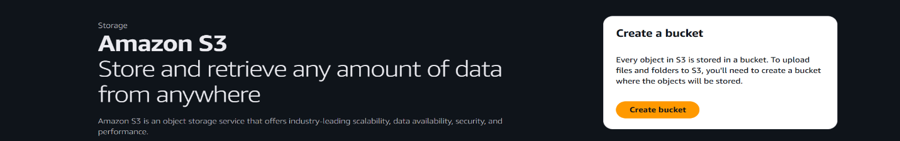

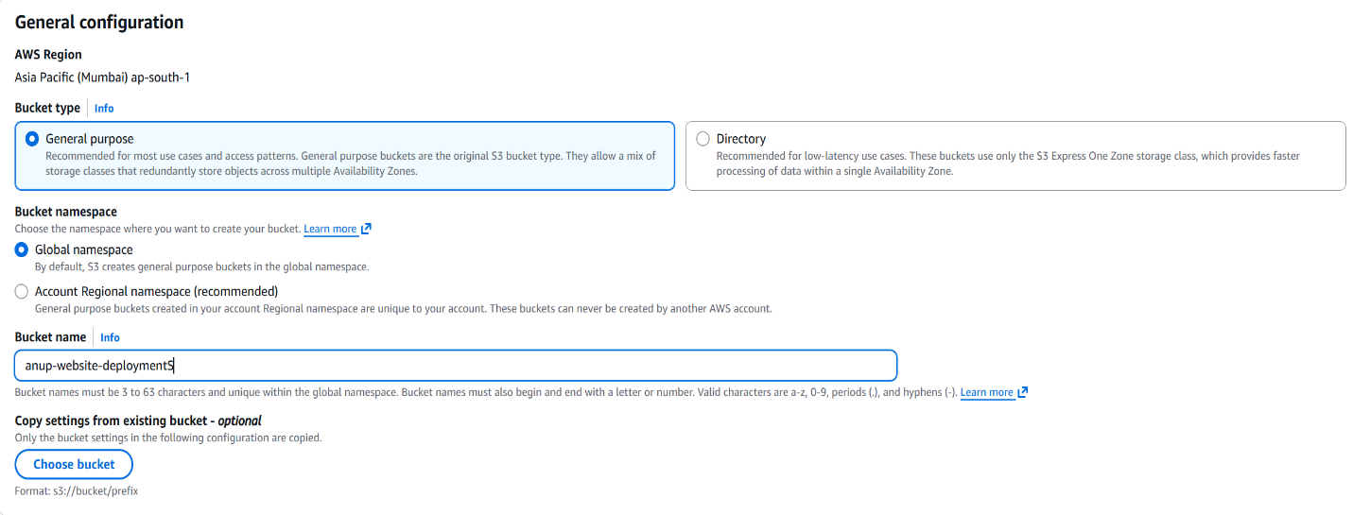
Step 2 : Setting up the Object Ownership
Select “ACLs (Access Control Lists) enabled”. This setting lets the bucket owner control access to individual files. It is useful when making specific files public for website hosting. Within this, the “Object Writer” setting is to be selected.
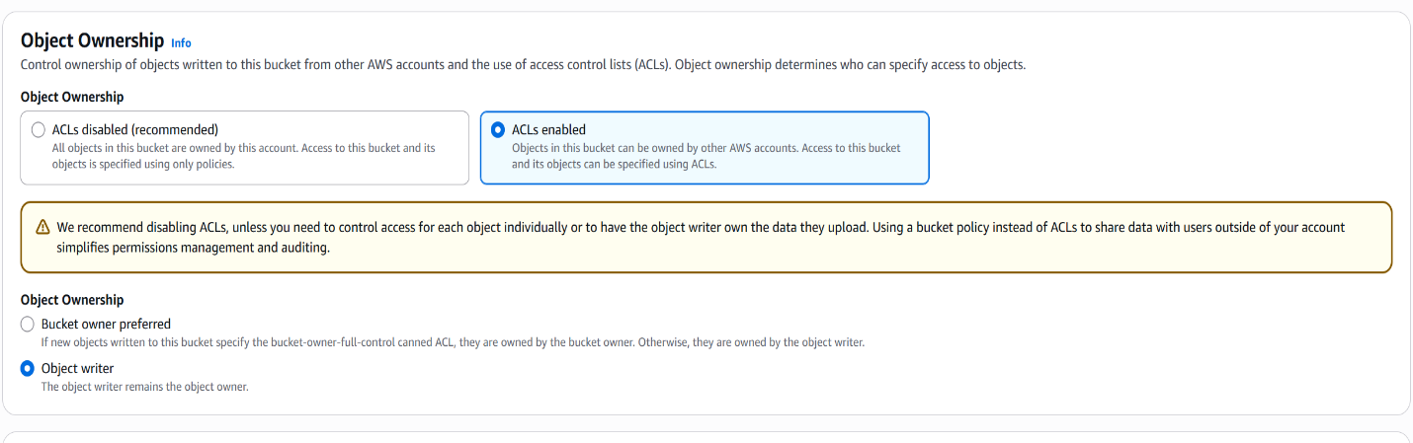

Step 3 : Block Public Access
By default, AWS blocks all public access for security. This option should be unchecked to allow the website to be accessible to everyone on the internet. Without disabling this, the website cannot be viewed publicly
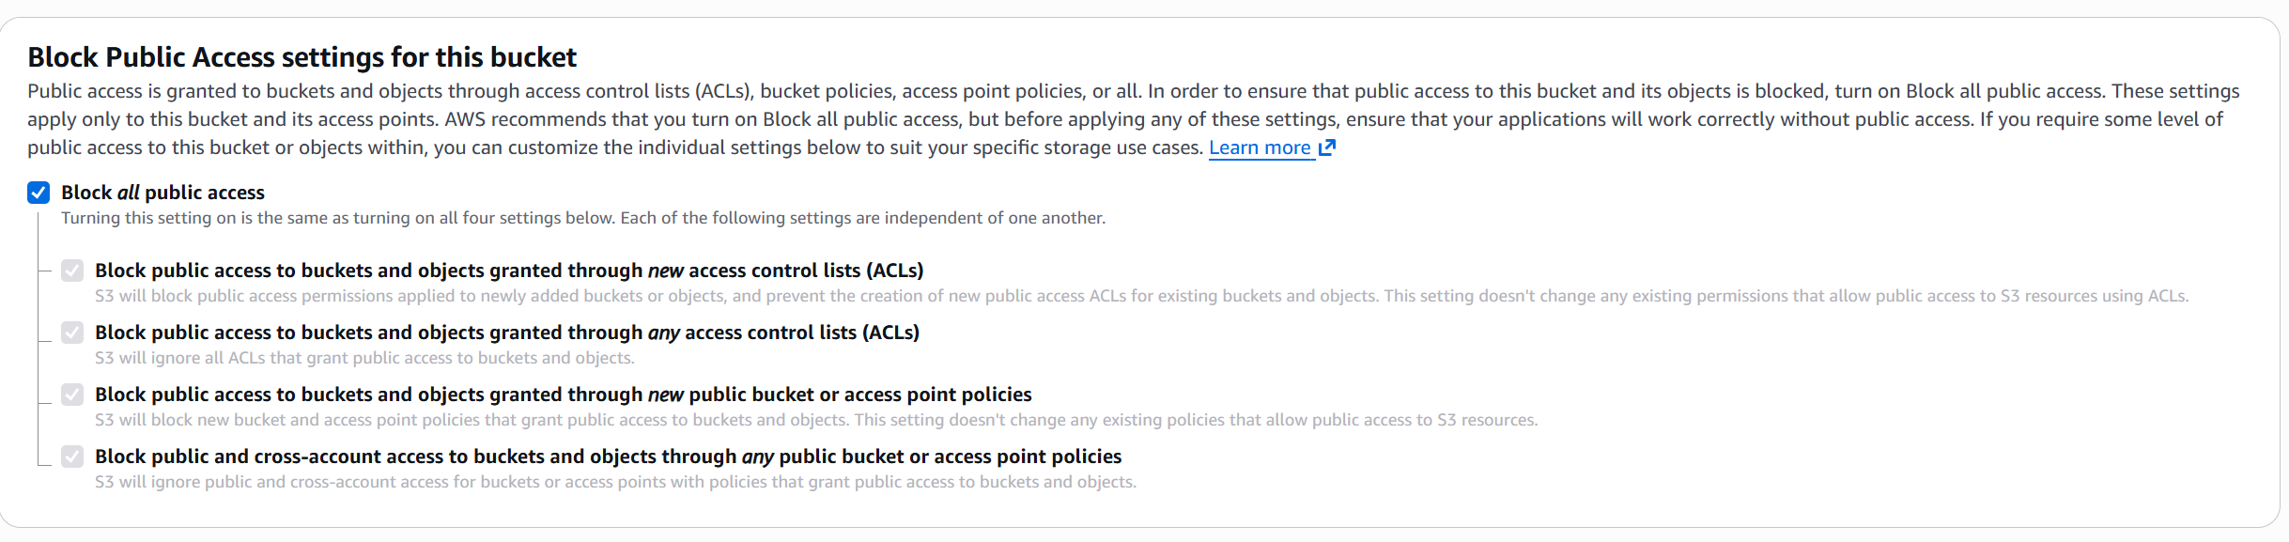
Step 4 : Default Encryption
This ensures that all data stored in the bucket is automatically encrypted.It improves security by protecting stored files without requiring manual encryption. Within this, Bucket Key should be enabled.
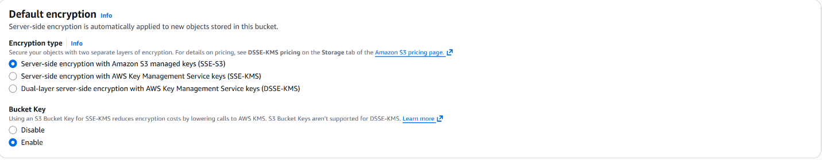
Step 5 : Upload Website Files
You upload your website files to the S3 bucket so they can be hosted online.
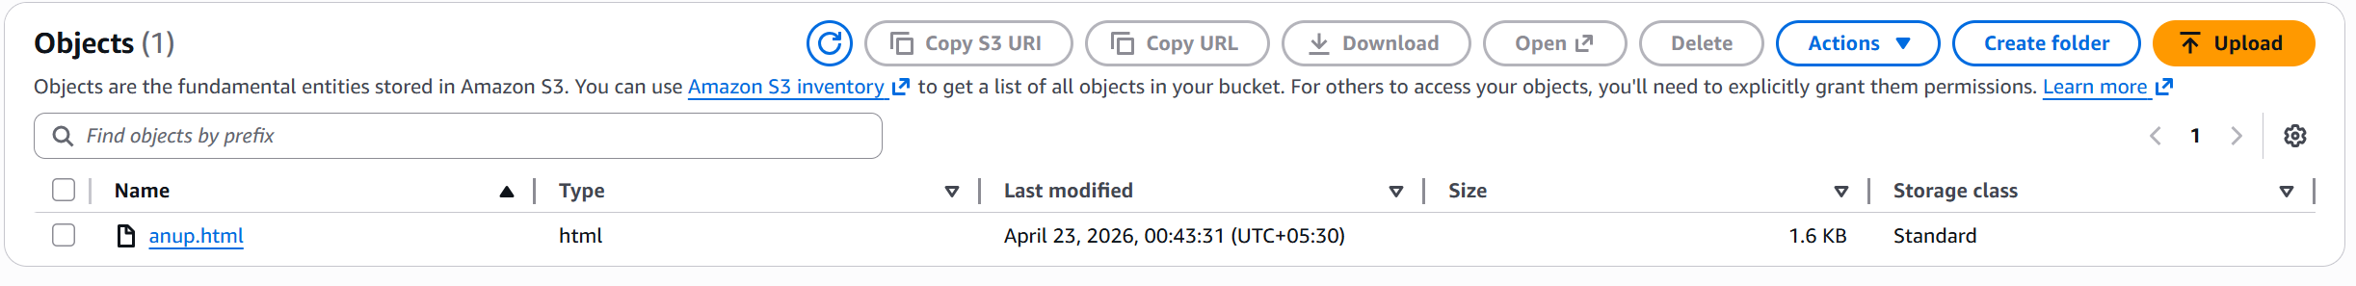

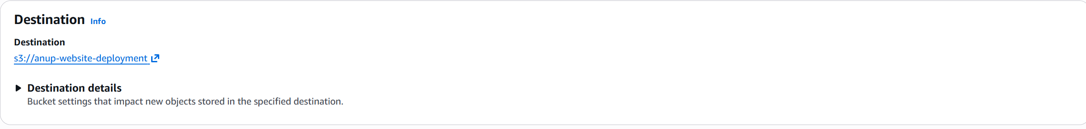
Step 6 : Verify the Uploaded Files
Here you can confirm if your files have been uploaded successfully to the bucket

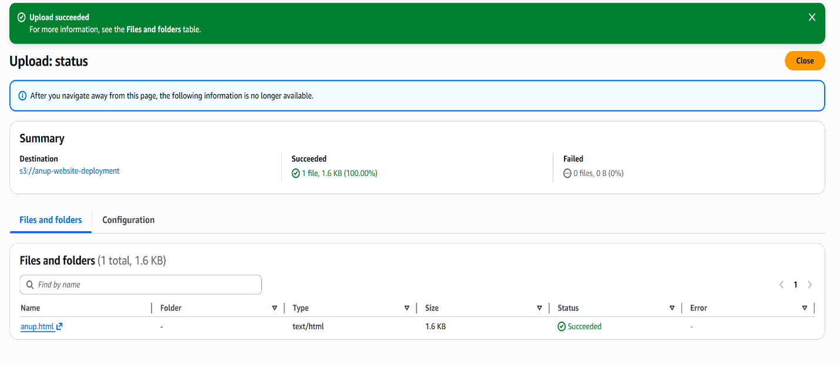

Step 7 : Make the Files Public
You make your file publicly accessible so anyone can view it using a URL
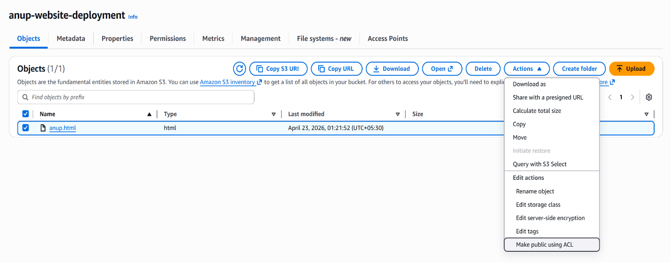

Step 8 : Confirm Public Access
This step confirms and applies public access to your files, making it accessible to the public audiences/viewers

